
Comsats University Islamabad, Lahore Campus
Course Title | Information Security | Course Code |  | CSC432 | Credit Hours |  |  | 3(2,1)
Instructor/s | Dr. Muhammad Sharjeel | Program Name |  | BSSE
Semester | 8th | Batch | FA21 | Section | A | Date | March 4, 2025
Time Allowed | 1 week | Maximum Marks
Student Name: | Aoun-Haider | Reg No. |  | FA21-BSE-133
Assignment <1> – SPRING 2025
Question no. 1
- Find the IP addresses of www.google.com, facebook.com, and cuilahore.edu.pk
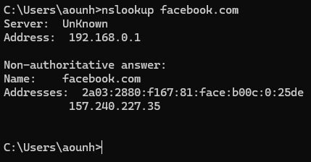
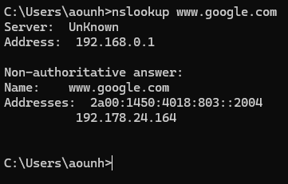
- Can you locate where these servers (computers) are?
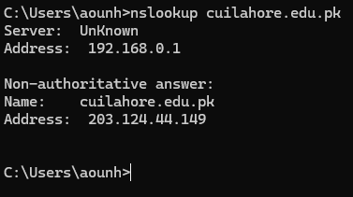

DNS server with name “UnKnown” which is responding to my request. 192.168.0.1 is the IP Address of my local router. Non-authoritative answer means that google is not directly responding to my request, instead some intermediary server is responding to the query. It might have placed the address in its cache. I have used nslookup command on command prompt in Windows 11 operating system. This command is useful for querying DNS server to obtain IP address. I found where servers are located using an online website https://ipinfo.io/account/search to obtain geolocation by first finding the IP address using nslookup.
So, the IP Address of these websites is:

Website | IP Address | Geolocation
www.google.com | 192.178.24.164 | Hostname: mct04s02-in-f4.1e100.net
 |  | City: Muscat
 |  | Region: Muscat
 |  | Country: Oman (OM)
 |  | Location (Latitude, Longitude): 23.5841, 58.4078
facebook.com | 157.240.227.35 | Hostname: edge-star-mini-shv-01-mct1.facebook.com
 |  | City: Barkā’
 |  | Region: Al Batinah South
 |  | Country: Oman (OM)
 |  | Location (Latitude, Longitude): 23.6787, 57.8860
cuilahore.edu.pk | 203.124.44.149 | Hostname: host202003.comsatshosting.com
 |  | City: Rawalpindi
 |  | Region: Punjab
 |  | Country: Pakistan (PK)
 |  | Location (Latitude, Longitude): 33.5973, 73.0479
Question no. 2
Modify your PC’s hosts file to map www.google.com to Facebook’s IP address and try to do a google search. What happens? Remove the modification to the host file and repeat.
I modified host file at C:\Windows\System32\drivers\etc\ which represents domain name to IP address mapping, by entering the entry 157.240.227.35 www.google.com at the bottom and when I queried google.com in browser, it gave me this error:
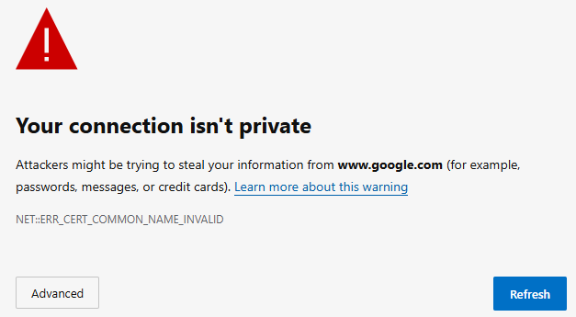
This is because every server returns a certificate (which proves that it is what it claims to be), when browser compared received Facebook’s server certificate with google.com, I attributed it as a threat.
When I commented the last entry in host file and again queried the browser, website opened normally.
Question no. 3
Find the domain name of 111.68.103.178 (reverse the address and add .in-addr.arpa). Why you added .in-addr.arpa to the reverse address, what is its purpose?
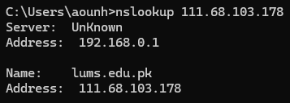

I have used nslookup again to find the domain name, it internally automatically reverse the IP address and add .in-addr.arpa internally and returns the domain name which is lums.edu.pk in this case.
Question no. 4
Can you find the owner of cuilahore.edu.pk, chatgpt.com, netflix.com, and espncricinfo.com domains? How can this information be helpful to an attacker?
I have only found name server information for each domain using nslookup –type=NS cuilahore.edu.pk. This information can be used by hacker to directly target the website an perform DDOS or any other vulnerable attack.
Domain | Name Servers | IP Address
netflix.com | ns-81.awsdns-10.com | 205.251.192.81
 | ns-659.awsdns-18.net | 205.251.194.147
espncricinfo.com | ns-475.awsdns-59.com | 205.251.193.219
 | ns-1329.awsdns-38.org | 205.251.195.91
chatgpt.com | hassan.ns.cloudflare.com | 108.162.195.149
 | savanna.ns.cloudflare.com | 2606:4700:58::a29f:2c95
cuilahore.edu.pk | n1.comsats.net.pk | 210.56.11.130
 | n2.comsats.net.pk | 203.124.45.92
Question no. 5
Find the complete route from your PC to www.deepseek.com.
I have used traceroute command which provides IP addresses of maximum 30 between source and target with the time taken. It took 7 hops to reach the destination 104.18.27.90 from source 192.168.0.1
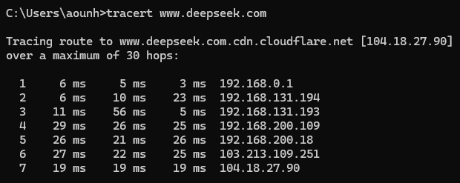
Question no. 6
Find the MAC address of your PC. What command did you use?
The question contains ambiguity, because although mac address is only one for each pc but each computer has more than one interfaces and each interface has a separate mac address. For example, in my case, my computer has a separate interface for WIFI connections, separate interface for Bluetooth connection and separate for LAN connection. So, I am using getmac command which returns mac address of all interfaces except virtual then I will use ipconfig which is more advance because it returns more detailed information. Sample run of getmac is given below:
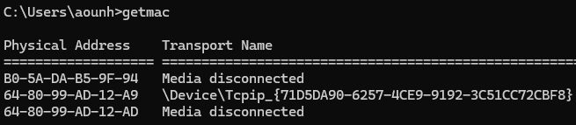
Now as we can see, my computer has three interfaces and only one among them is connected which is WIFI adaptor.
Now running ipconfig/all command to get more detail information:
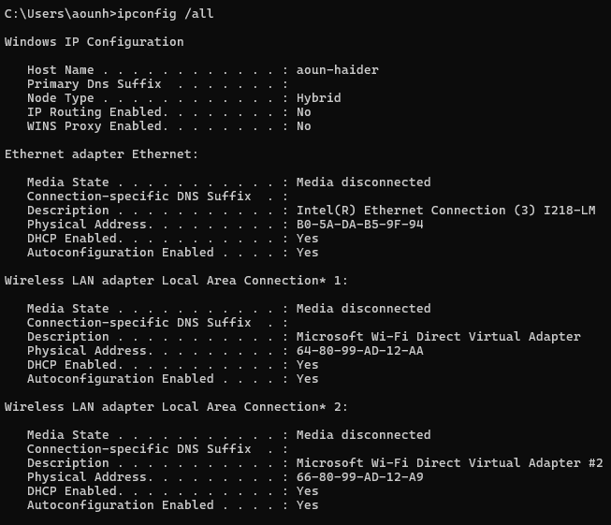
This command has also showed Microsoft Virtual Adaptor’s mac addresses which are used for hotspot connection, screen mirroring, direct WIFI (without router for sharing between PCs or connecting a wireless printer)
So, the active MAC address (Wireless LAN Adaptor) is 64-80-99-AD-12-A9
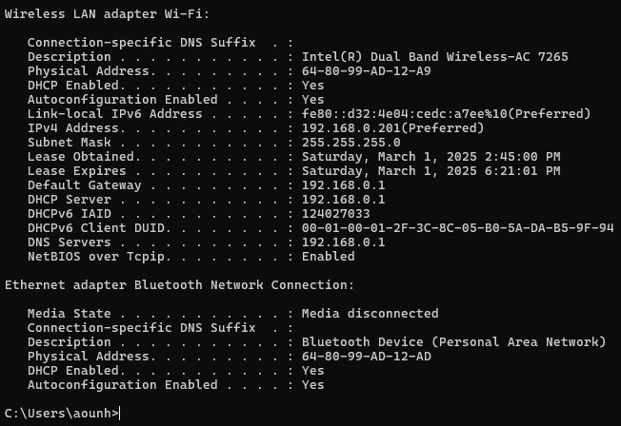
Question no. 7
Print your PC’s ARP cache table. Can you change any entry in the table? What will happen if you modify your PC’s ARP table?
We can use arp –a command to print the PCs ARP table which represents the IP address of the sites which are once visited and now if again visited, their address will be entertained by this ARP table.
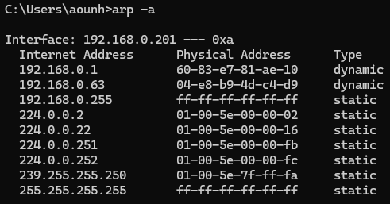
After adding IP address with invalid MAC address using arp -s, I have tested using ping command and timeout occur then I removed the added entry and again ping the same IP address and now timeout not occurred.
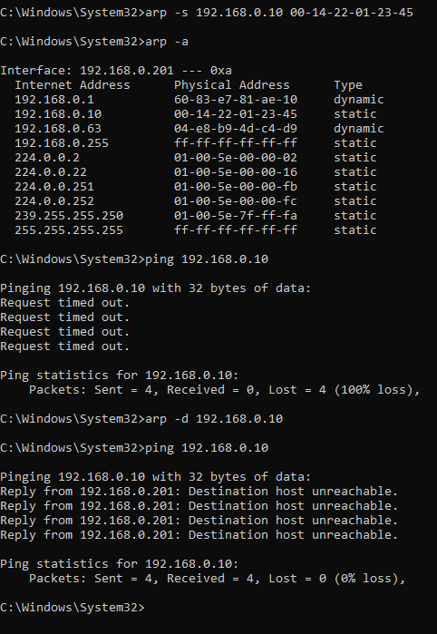
Question no. 8
Print the routing table on your PC and explain each line (first 10 lines, if too many).
There are 3 sections in the result of print route command:
Section-1: Interface list shows all the interface with their corresponding mac addresses
Section-2: IPV4 route table shows all the IP addresses with their subnet mask, responsible interface from above discussed available interfaces and matric which shows the priority, lower the matric, higher will be priority. Default route is 0.0.0.0 which is handled by WIFI interface, On-link gateway represents the loopback routes.
Section-3: Similar to previous routing table but for IPV6 addresses.
All outbound traffic passes through default gateway (192.168.0.1), my router. Loopback traffic for testing internal communications. Devices in the same subnet are directly reachable and requires no gateway.
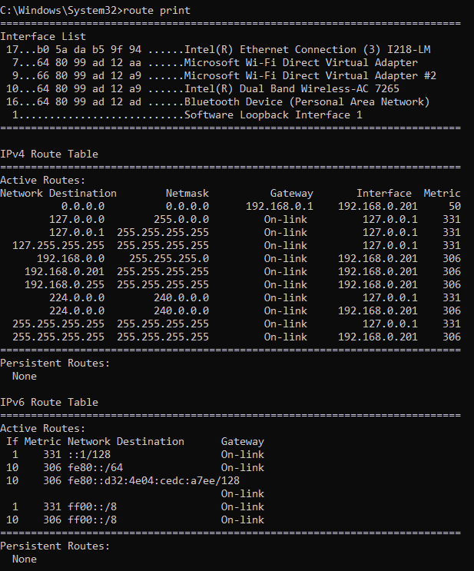
Question no. 9
Find the location of 111.68.103.27
I have used https://ipinfo.io/account/search website to obtain information:
Hostname | pu.edu.pk
City | Lahore
Region | Punjab
Country | PK
Location (Latitude, Longitude) | 31.5580, 74.3507
Question no. 10
Run ‘netstat -abon’ on your PC. What information does it displays? What is the name of the process listening on port 3389? What is the status of port 3389? Why it is important for an attacker?
When I executed the command, it showed me list of all the connections with the ports listening to them and the active programs or processes listening to the connections with their process IDs, connection status (ESTABLISHED, LISTENING, CLOSE_WAIT).
I used netstat -abon | findstr :3389 to find the status of this port, but there is no program running on my PC on this port. It is for remote desktop protocol. To protect from attackers, we can:
- use different port as compared to standard port number
- Ensure firewall or VPN is activated and working
- Disable RDP (Remote desktop protocol) if not needed.
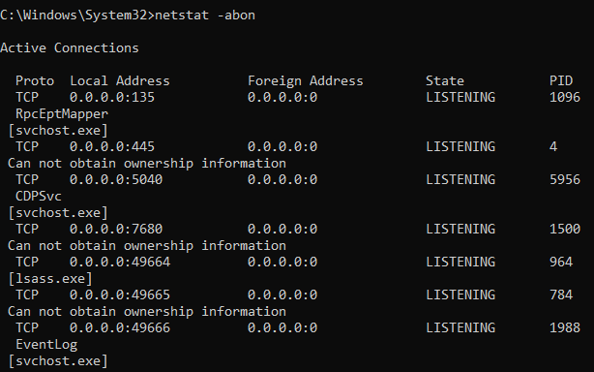
Question no. 11
Run ‘netsh wlan show profile’ on your PC? What information does it show? Can you recognize all the user profiles?
This command showed all the saved WIFI profiles on my PC or connections I made in past. It is helpful for system to keep track this information so that in future if my pc is near any of these WIFI, my device will automatically connect to that WIFI (plug & play devices feature) without the hustle of re-entering password again until not changed as compared to saved one.
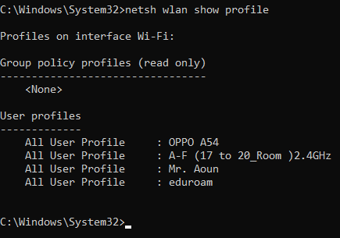
In the above sample run, 4 saved profiles are shown.
Question no. 12
Run ‘query user’ on the command line and interpret what it displays?
This command is not working on my PC as I am using Windows Home, I found another variant of this command whoami which shows currently logged in user information which is mr. aoun haider in my case.
